Satej Sukthankar Period 8

**Patrick’s Bad Day**

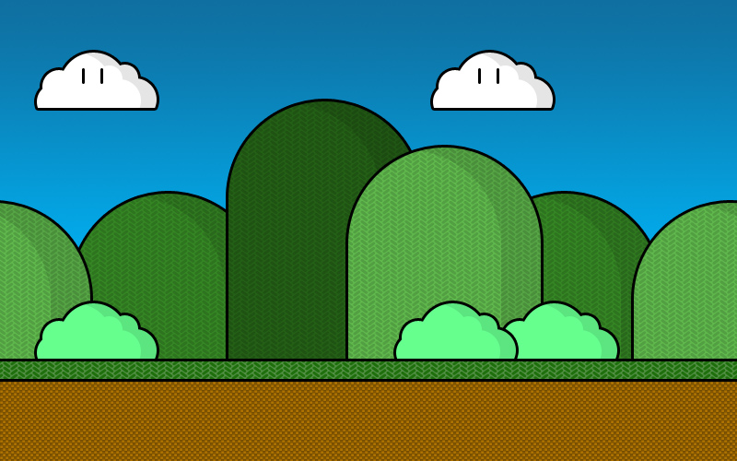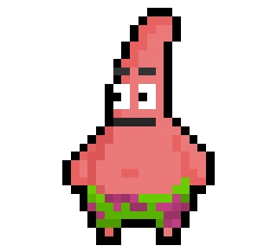 Basically, Patrick Star is going to be the main character and is playable. The player moves Patrick to the end of the level, where he proceeds to become happy. There will be multiple levels and the player will have 3 lives. The player will be able to shoot pellets using a key and the pellets can defeat enemies they encounter. There will also be platforms that the main character can jump on so that they can avoid enemies.

Patrick’s character model

The side-scrolling background screen

Game over screen, probably?